Diana Rodriguez, DMD  2406 Bergenline Ave.  Union City, NJ 07087  http://www.dianarodriguezdmd.com/ | 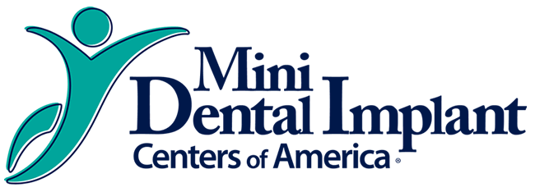

PATIENT CONSENT FORM

I understand that, under the Health Insurance Portability & Accountability Act of 1996 (HIPAA), I have certain rights to privacy regarding my protected health information. I understand that this information can and will be used to:

- Conduct, plan and direct my treatment and follow-up among multiple Healthcare providers who may be involved in that treatment directly and Indirectly
- Obtain payment from third-party payer
- Conduct normal healthcare operations such as quality assessments and Physician certifications

I have received, read and understand your Notice of Privacy Practices containing a more complete description of the uses and disclosures of my health information. I understand that this organization has the right to change its Notice of Privacy Practices from time to time and that I may contact this organization at any time at the address above to obtain a current copy of the Notice of Private Practices.

I understand that I may request in writing that you restrict how my private information is used or disclosed to carry out treatment, payment or health care operations. I also understand Dr. Rodriguez’ office is not required to agree to my requested, restrictions, but if they do agree then they would be bound to abide by such restrictions.

Patient Name: ____________________________________
Relationship to Patient: _____________________________
Signature: ___________________________________
Date: ___________________________________

